**National University of Computer & Emerging Sciences, Karachi**

**Artificial Intelligence-School of Computing**

**Fall 2023, Lab Manual - 01**

|  |  |
| --- | --- |
| **Course Code:** | **Course: Computer Vision Lab** |
| **Instructor(s):** | **Sohail Ahmed** |
| **Student Name:** | **Manahil Fatima Anwar** |
| **Roll Number:** | **20K-0134** |
| **Section:** | **BAI-7A** |

**Lab Tasks:**

1. **Grocery List:** Your task is to create a simple program to manage a grocery list. Your program should allow the user to add items to the list, remove items, and display the current list of items. Write a Python program that implements this grocery list management system.

**Answer submitted on email.**

1. **Student Record System**: Your task is to build a simple student record system. Each student is identified by their student ID, and you need to store their names and corresponding grades. Your program should allow adding students, updating their grades, and displaying the student records. Write a Python program that implements this student record system using a dictionary.

**Answer submitted on email.**

Reference Images:

Image 01:

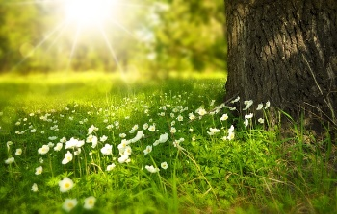

Image 02:

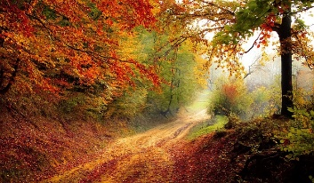

1. Load an image from file and display it, convert to grayscale, resize it to specific size using OpenCV.

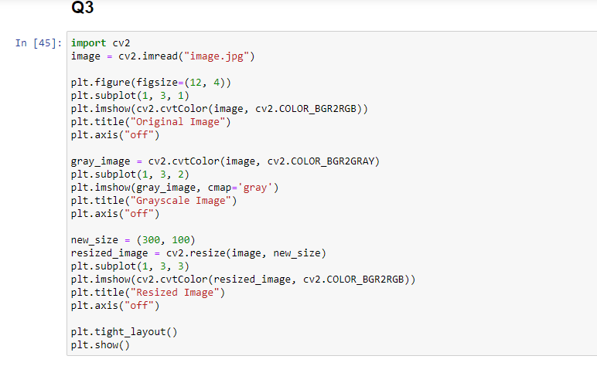

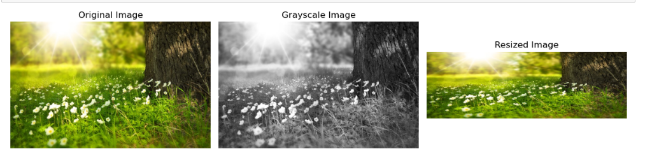

1. Create a blank image and draw basic shapes like rectangles and circles on it using OpenCV.

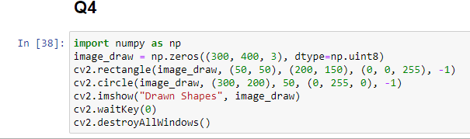

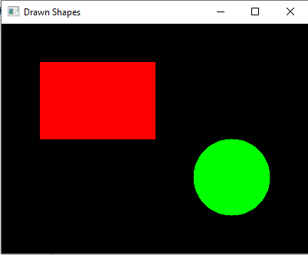

1. Load an image and apply Gaussian blur, crop at specific region using OpenCV, NumPy array slicing.

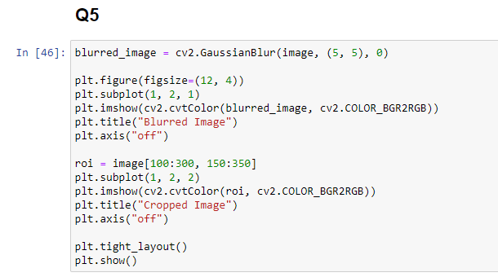

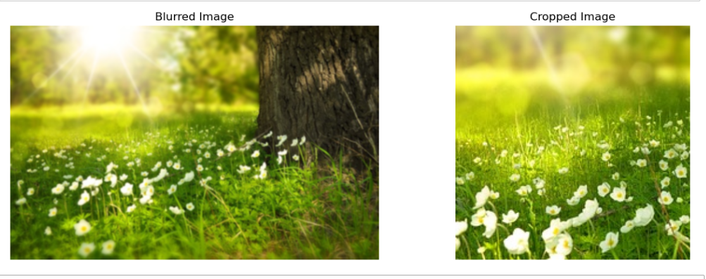

1. Load an image and add text to it using OpenCV, repeat this for creating a blank image and add text on that as well.

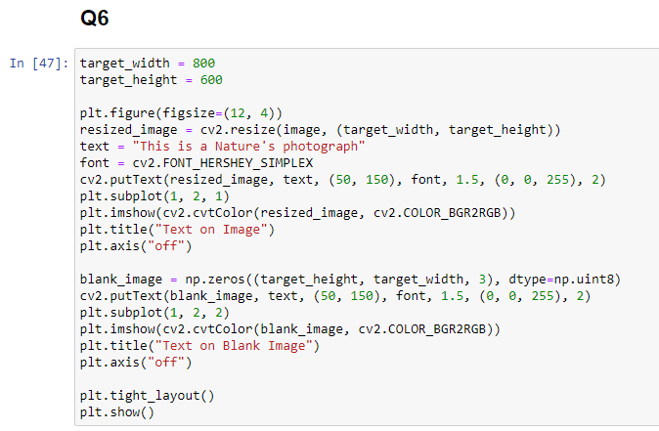

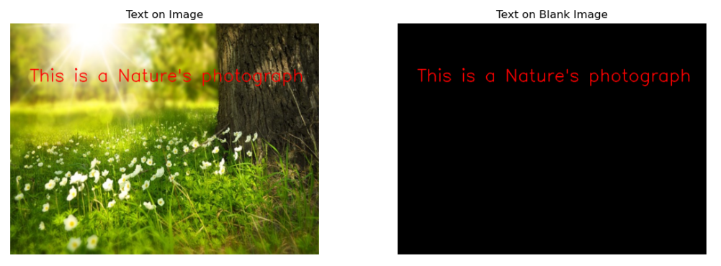

1. Load a grayscale image and apply binary thresholding to it and the rotate at 600 using OpenCV.

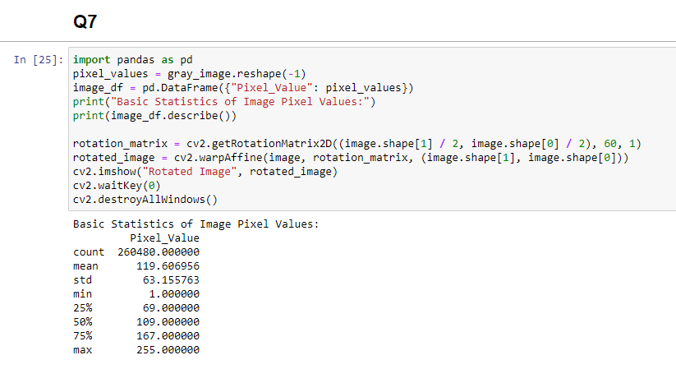

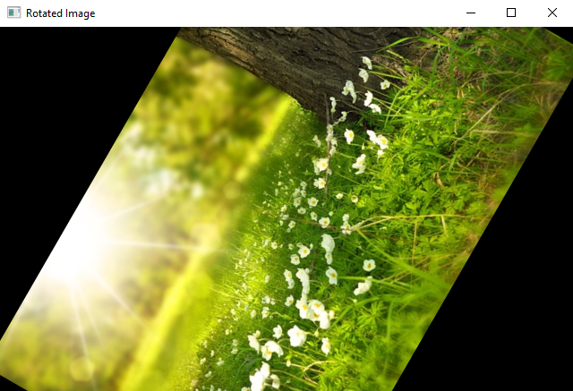

1. Load two images and blend them using OpenCV, and the convert it to grayscale and apply histogram equalization to enhance contrast.

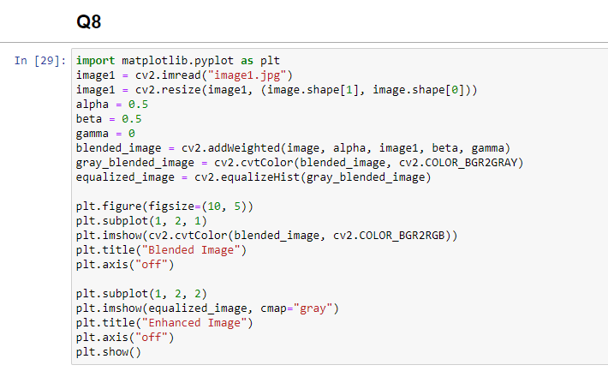

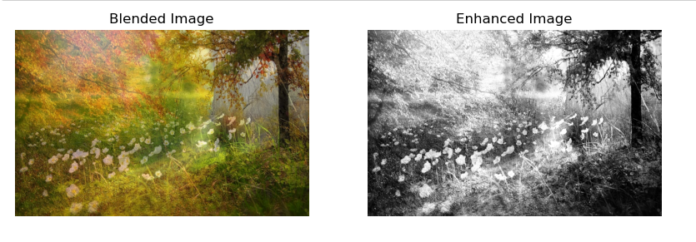

1. Create binary images and perform bitwise AND, OR, XOR, and NOT operations using OpenCV and NumPy.

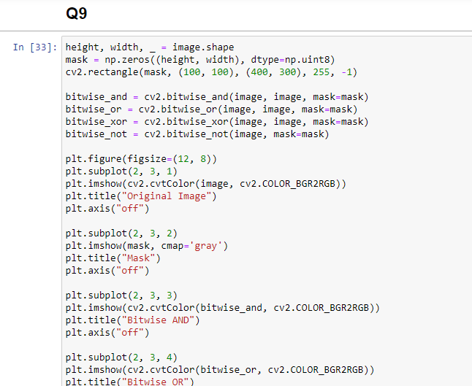

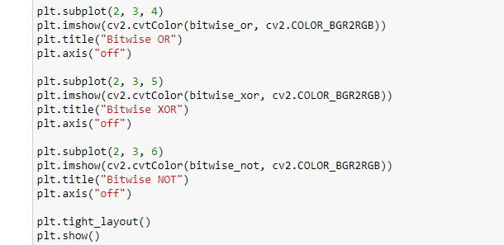

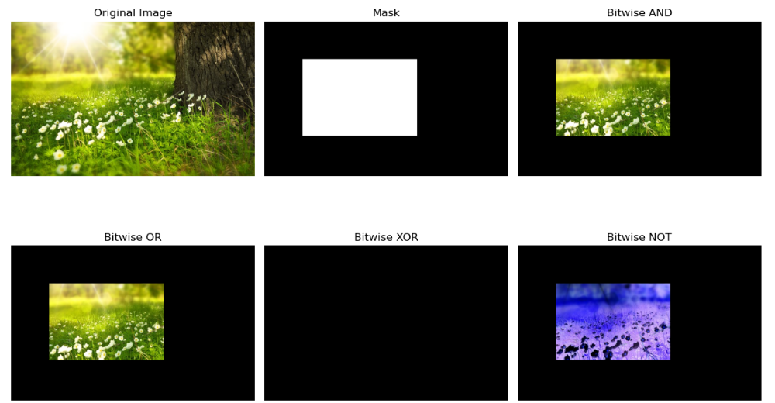

1. Load an image and convert its pixel values to a Pandas DataFrame, then analyze basic statistics, also apply a mask to it using bitwise AND operation.

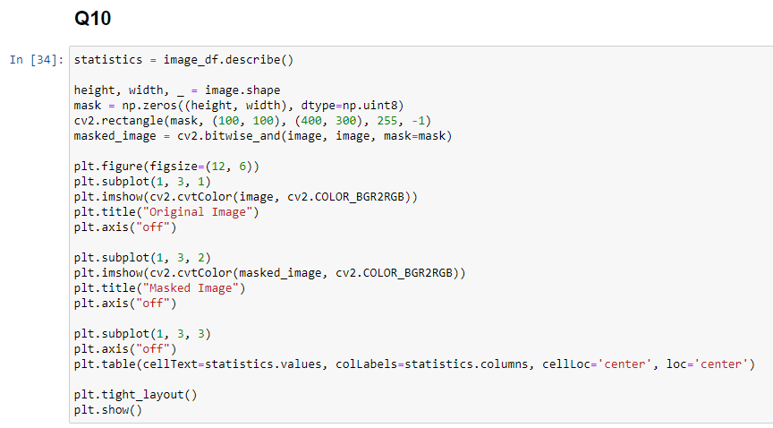

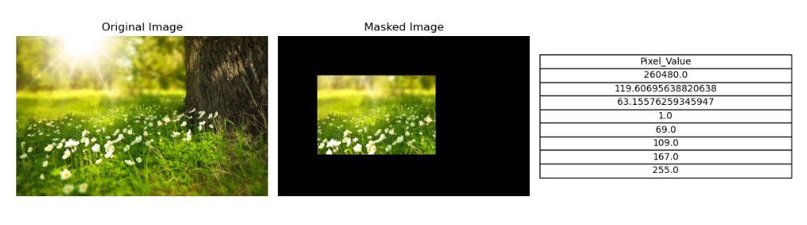

***Note: Use Subplot function where more than one image is required to be displayed/shown***.